Pony Club Pairs Dressage Test
  - Spread the word—let’s ride together!


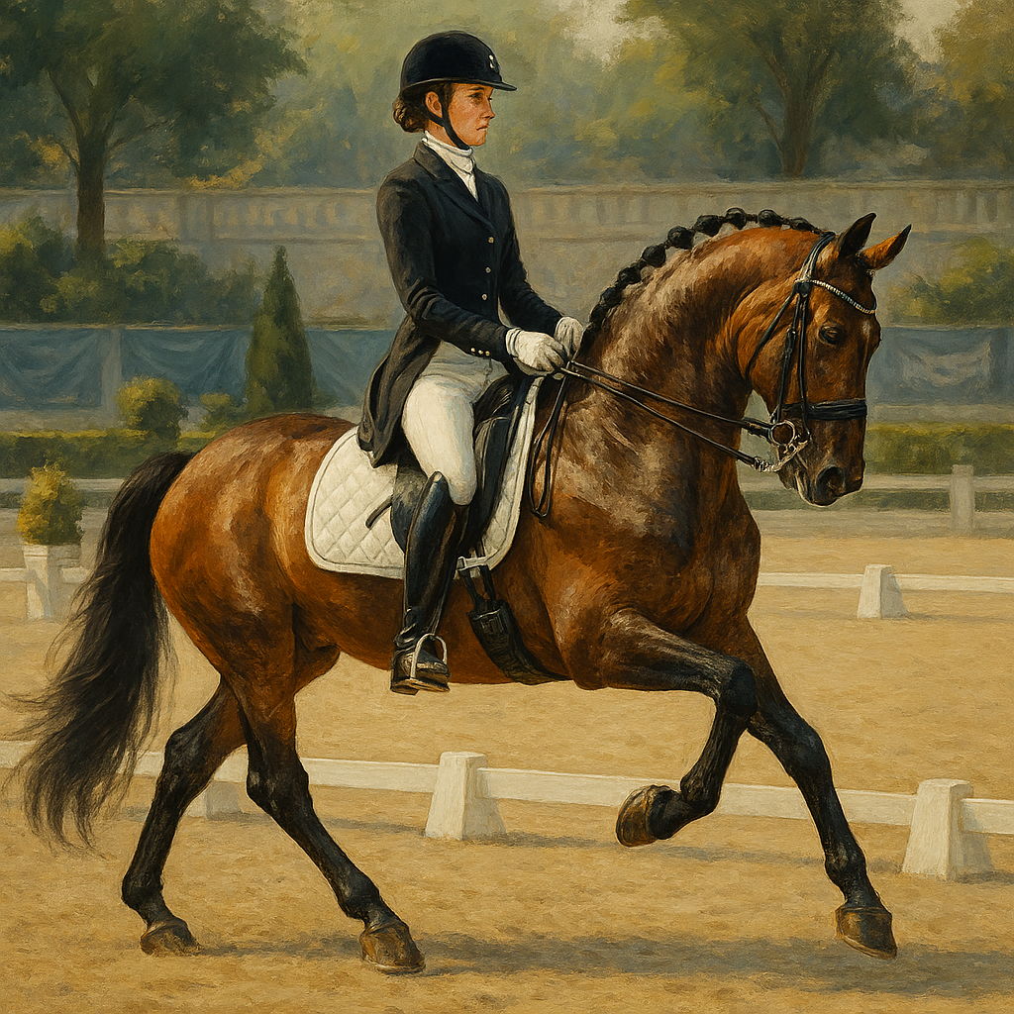
Join the Fun!

Make up your own test to complete in pairs – more information below
When: Tuesday 30th December 2025
Time: 9:30am – 13:00pm (prepare, practice and complete your test within this time)
How to Sign Up:
- Fill in the entry form: attached / please take one from the office.
- Pay your entry: £25 per rider.
- Any questions? Ask Amelia or call 07974 798928.
About the event:
- Relaxed and fun dressage event to celebrate 2025!
- Research dressage tests (ask for help if you need it).
- Make your own test in pairs – walk and trot / walk, trot and canter.
- Total length of test should be 5 minutes.
- Both will ride the test separately for combined scores.
- Test can be to music – please let us know when booking.
- Can be themed (rider outfits or costumes only).
- Can be read out by your partner.
- Can be ridden with a leader if in walk and trot.
- Pair will share a horse, and both will ride the test.
- If you don’t have a partner, let us know, we will find you one!
- All riders must wear their safety gear (helmets, boots, etc.).
- Dressage tests follow Pony Club and British Dressage rules.
Booking forms, payments, tests, music and preferred horse to be completed and approved before the 28th December.
Tests can be handed in earlier for checking, in case any changes are suggested by your instructor.
We can’t wait to see everyone and their ponies in action!

Rider 1 Name | ___________________________
Rider 2 Name | ___________________________
Horse of Choice | ___________________________
Music of Choice (if any) | ___________________________
[ ] Up to date Pony Club membership
[ ] Payment made (£25 per rider)
[ ] Costumes/outfits to be worn
Emergency Contact Name | ___________________________
Relationship to Rider | ___________________________
Contact Number | ___________________________
Please complete and return this form to the office before 28th December. If you need help finding a partner or have any questions, contact Amelia or call 07974 798928. All riders must wear safety gear (helmets, boots, etc.) and follow Pony Club and British Dressage rules.

